Lab setup for
Angular 11

Required software’s to be installed (All are free and open source software)
- Google chrome browser (Free and Open source)
- VScode editor (Free and Open source)
- Angular version 11 (Free and Open Source)

Software Requirements (All are free and open software)
- Download and install Google Chrome Browser any latest version
https://www.google.com/intl/en_in/chrome/

- Download and Install Node JS version 18.12.1 from: (Extractable)
https://nodejs.org/dist/v18.12.1/node-v18.12.1-win-x64.zip
Extract to local folder: (For example: C:\node-v18.12.1-win-x64)
Please see below for step-by-step installation
- Download and unzip VisualStudio code editor from (Extractable)
https://code.visualstudio.com/docs/?dv=winzip
Please see below for step-by-step installation
- Angular installation will be part of the training

- Open Internet Connectivity is mandatory
Also, verify the following proxy configuration setup:
These steps are required to install Angular8 during the session
ping www-proxy-idc.in.oracle.com (or)
ping www-proxy.us.oracle.com

npm config set proxy http://www-proxy-idc.in.oracle.com:80
npm config set https-proxy http://www-proxy-idc.in.oracle.com:80
(or)
npm config set proxy http://www-proxy.us.oracle.com:80
npm config set https-proxy http://www-proxy.us.oracle.com:80

Node JS Installation steps:

Download and Install Node JS version 18.12.1 from: (Extractable)
https://nodejs.org/dist/v18.12.1/node-v18.12.1-win-x64.zip
Select and download Windows Binary (.zip) as shown in the following diagram:

Extract to local folder: (For example: C:\node-v18.2.1-win-x64)
Go to this folder and you can see “node.exe”
Go to the command prompt and verify the version by invoking the following command:
node –version
If you are getting “not recognized as internal or external command” error, you need to set NODEJS installation folder to PATH environment variable
Open Environment Variables window, by clicking the windows start button and type “Environment Variables”

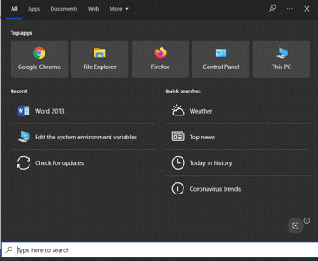

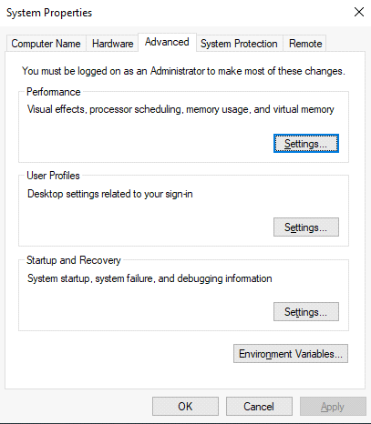
Click on ‘Environment Variables’
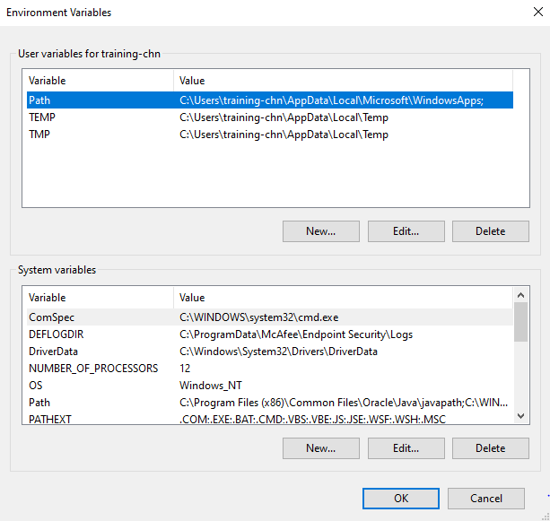

Search PATH in “User variables” section.

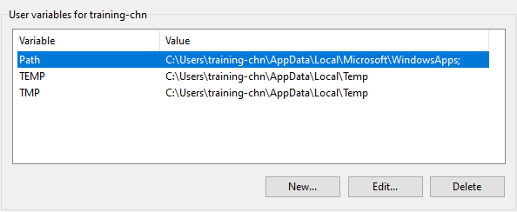

Select “PATH” and then click on ‘Edit’, next screenshot shown below
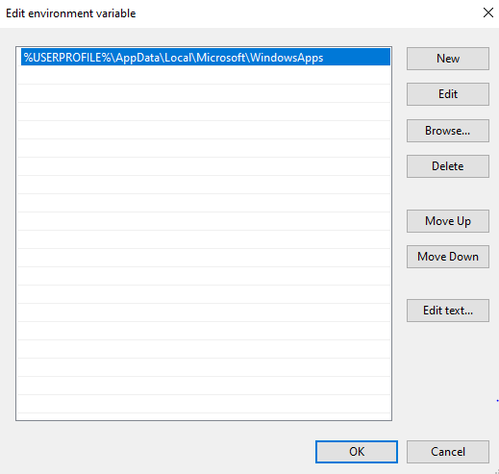
Click on ‘New’
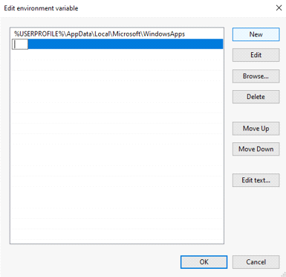
Copy and paste the NodeJS installation folder path i.e. ‘C:\node-v18.2.1-win-x64’

VSCode Installation steps:

- Download and extract .zip file into local folder (d:\ VSCode) from https://code.visualstudio.com/Download
Visit the website https://code.visualstudio.com/Download
Click on .zip file (64 bit)
It will download VSCode-win32-x64-1.73.1.zip in “downloads” folder
Create a folder “VSCode” in “C” drive: (Example: C:\VSCode)
Copy & paste the above zip file in this folder
Right click and unzip.
After unzip successful, go to the folder “VSCode-win32-x64-1.73.1”, you can see “code.exe”, double click on this and the VSCode editor will open

